Mr. Ketler
Rm. 338
Tamanend Middle School
kketler@cbsd.org
(267) 893-2900; Ext 6440

Course Description

9th Grade Science explores the complex and dynamic set of interconnected systems that interact over a wide range of temporal and spatial scales on Earth. National and state standards-based units take students on a journey through the geosphere, hydrosphere, atmosphere, and biosphere allowing them to discover how these systems have and continue to change over time. The units provide context to understand the concepts as well as an understanding of the knowledge and processes of science. The course builds upon science topics that students are introduced to throughout middle school and lays the foundation for further exploration of science through high school.

OVERVIEW OF UNITS AND TOPICS COVERED THIS YEAR:
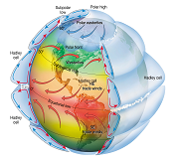
UNIT 3: ATMOSPHERE

- Earth’s Atmosphere
- Weather and Climate
- Interactions with the Atmosphere

UNIT 4: BIOSPHERE

- Theory of Evolution
- Genetic Variation and Speciation
- Phylogeny
- History of Life on Earth

UNIT 5: HUMAN INTERACTIONS

- Ecosystems
- Human Population Growth
- Conservation

UNIT 1: GEOSPHERE

UNIT 2: HYDROSPHERE

- Our Oceans
- Properties of Water
- Ocean Chemistry
- Physical Oceanography

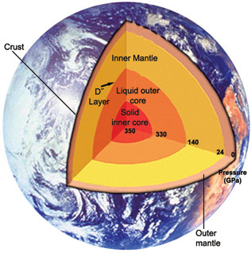

- Earth’s Changing Surface
- Earth’s Structure
- Plate Tectonics
- Earth’s History

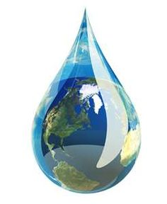



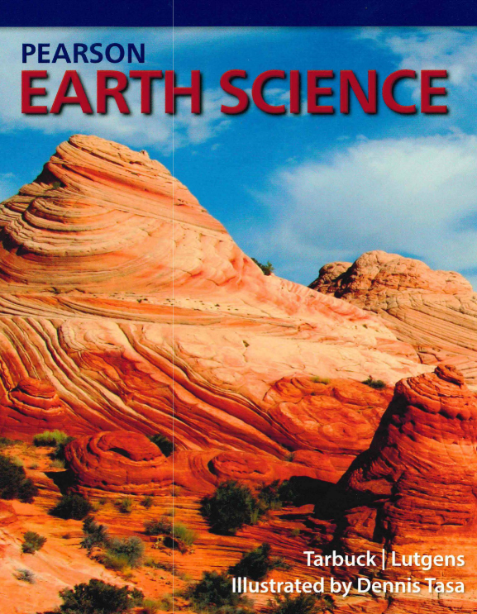
Requirements

- District Issued Laptop
- Earth Science Textbook (Online or Physical)
- Earbuds
- Pen/Pencil
- Binder

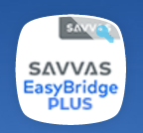
Textbook: We will be using Pearson’s Earth Science textbook. You will have access to the online version of the Pearson Earth Science textbook via SAVVAS Easy Bridge App located on MYCBSD Class link. Please contact me if you prefer a physical copy of the textbook.

Online Resources

 | Canvas will be used to complete and submit summative assessments (tests, projects, labs, etc.). Canvas will also contain learning modules based on course content. Students can access Canvas via MYCBSD (ClassLink) or their Office 365 account.
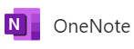 | OneNote is an option that students may use to construct and store class notes as well learning tasks completed during class and at home. Students can access OneNote via their Office 365 account.
Pearson Earth Science | Students can access our online textbook Pearson Earth Science via the SAVVAS App. Students can access SAVVAS Easy Bridge via MYCBSD (ClassLink) or their Office 365 account.

Grading System

A student’s marking period grade will be based upon the percentage of the total number of points accumulated by the student on summative assessments. Results of formative assessment (practice assignments) will be recorded in Infinite Campus (student/parent portal); however, will not factor into the final grade for the marking period.

- 100% Summative Assessments can accurately be described as academic achievement. When students have had time to practice and receive feedback (their own feedback and the teacher) on skills and concepts, they will have the opportunity to be assessed on their understanding and application of the skills and concepts via tests, lab analysis, and projects.
- 0% Formative Assessments are academic practice. These assessments take place daily and in a variety of forms in the classroom. They are used as students learn new concepts, providing an opportunity for teachers to determine each student’s level of understanding of skills and concepts. Examples include Canvas Review Quizzes, student notes, and enrichment activities where students may receive feedback.

Submission of Work

It is the expectation that all assignments will be handed in either before or on the due date. Due dates are communicated to students in advance both in class and through Canvas. Mr. Ketler will designate if an assignment will be submitted via Canvas or “On Paper”. Assignments that are not completed will receive a grade of “Missing” until the assignment is handed in. Late work will be accepted within a reasonable amount of time.

Reassessment (Second Chance Opportunity)

Reassessment opportunities for summative assessments allows students an opportunity to demonstrate an improved understanding of the content after a relearning process following an initial assessment. Reassessments are not meant for the sole purpose of getting a better grade; they are intended for students invested in achieving mastery of the content and related skills. Students may earn up to a 90% on reassessment (second chance opportunity). Please follow the guidelines below for reassessment (second chance opportunity):

- Review initial assessment results and teacher feedback.
- Contact Mr. Ketler to schedule remediation and reassessment attempt during resource, I&E Extended Advisory, or after school.
- Check Parent/Student Portal for missing formative assignments assigned for the chapter. Complete missing assignments and review your work prior to attempting a reassessment opportunity.
- Students have 3 days from the date that test results are released to begin remediation and reassessment.

Core & Performance Assessments

Unit Tests | Core Assessments
Unit 1: Geosphere | Ocean Acidification Performance Assessment
Unit 2: Hydrosphere | Land and Sea Performance Assessment
Unit 3: Atmosphere | Peppered Moth Performance Assessment
Unit 4: Biosphere
- These assessments are to be given during or soon after the unit is taught. The 4 Unit Test grades are to be accumulated and reported as the final exam grade. Core Assessment grades will also count toward your final grade.
Classroom
Respect  - Take care of property.  - Listen to others.  - Maintain personal space.  - Choose your words wisely. | Act Appropriately  - Actively participate  - Problem-solve.  - Follow directions.
Own Your Behavior  - Be prepared, organized and on time.  - Show self-control.  - Advocate.  - Engage in the lesson. | Remember Kindness  - Engage in positive interactives.  - Stand up or others  - Cooperate.

Expectations

